Pre-Reading

Our City
The first new character in this reading is 们 (men). This character can be added to most words which refer to people to make it plural. Thus 我们 means we and 我们的 means ours. Aside from pronouns, 们 can be added to other nouns to make them plural, such as 老师们 (teachers) and 学生们 (students). The next new word is 城市 (cheng2shi4), which means city. Today 城 means city, but in ancient times it actually meant wall. 市 also means city. Thus, 城市 would have in ancient times literally translated to a walled city. You also have probably heard of the great wall, which in Chinese is actually 长城 (chang2cheng2), which literally means long wall. In the second sentence, you read that the 城市只有 (zhi3you3) 只 means only or just and 有 means to have, thus the city the speaker refers to only has 一个大学, one university. The first character in the following sentence 这 (zhe4) means this. As you learned in the first reading, 叫 means to be called. However, it is not only limited to people; it can also be used to refer to places and things. The town of Logan 只有 "两个(liang4ge4)" 医院(yi1yuan4) and 三个(san1ge4) 超市(chao1shi4). In Chinese, just as in English, there are several ways to say two, and they are not always used interchangeably. For example, if you are counting something, you would not say I have 二个 something, instead you would say I have 两个 something. So as we find out, Logan only has two hospitals and three supermarkets. Thus, we can understand from the speaker’s use of 只 that he must consider this to be insufficient. 医 means medical and 院 means yard, so a hospital literally translates to medical yard. 超 means super or extra and 市, as you may remember from the word 城市, means city， but it also means market, so here it means supermarket. The last sentence begins with 虽然 (sui1ran2), which means although. After the comma in the sentence, you will see the word 但是 (dan4shi4), which means but. In Chinese, when constructing a sentence with although, it must be followed by but. For example, 虽然我很小，但是我很强 (qiang2), means "Although I'm very small, but I'm very strong." The speaker says, “Although Logan is very small, 这里 (zhe4li3) here (the city of Logan) is very 漂亮 (piao4liang) beautiful. 漂 means to float and 亮 means bright or clear. Thus something that is漂亮 appears as if it is floating in the sunlight.
Story Character Count = 46
Vocabulary/Writing
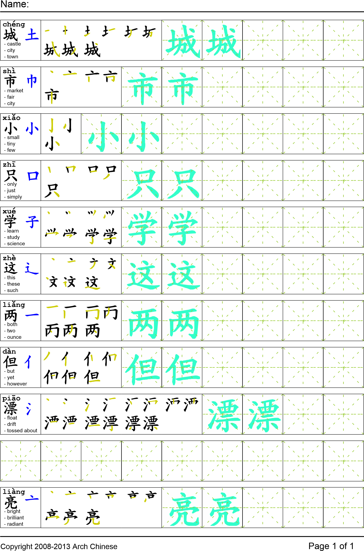
Reading

我们的城市很小。城市只有一个大学。这个城市叫Logan。在Logan只有两个医院和三个超市。虽然Logan很小，但是这里很漂亮。
Task Completion

Once all tasks are complete turn the assignment in to collect the points for the project.
Task 1: Trace the vocabulary and copy the story into your notebook.

Task 2: Answer Comprehension Questions

Task 3: Write the Pinyin for the Reading

Task 4: Translate the Reading into English

Task 5: Record yourself reading the passage.

Comprehension Questions
- What does the author think of Logan? ________________________________________________
- How do you make nouns plural in Chinese? ____________________________________________
- What are the three number words in this article? _______________________________________
- What does 漂亮 literally mean? _____________________________________________________

